Duplexing a GE MVP
And installing the NHRC-4/MVP repeater controller
By Peter Gailunas KA1OKQ

NHRC assumes no liability for any damages to your MVP or you inability to perform these modifications. If you have any doubt about your ability to perform these mods or install this repeater controller correctly seek professional assistance. Damage to your NHRC-4/MVP repeater controller caused by improper installation or hookup is not covered by the NHRC limited warranty.

Before you start working on your MVP, you should do a few things first. Be sure your MVP is working correctly before you make the mods. Be sure you have a service manual for your radio. This mod assumes you have a single channel radio. In multi freq radio’s be sure to select F1 if you remove the freq selector.
This procedure assumes that you have dealt with the TR relay by bypassing or defeating.

This document is the only support available for duplexing the MVP. No other assistance is available from NHRC regarding duplexing this radio

If you don’t have an MVP service manual STOP now and get one.

All duplexing mods are done on the System-Audio-Squelch PCB found under the front cover of the MVP GE pn 19C321920GX Shown below:
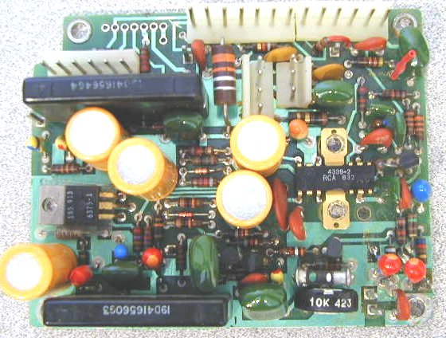

Step 1: Remove and discard the PL encoder/decoder assy if so equipped. Unplug the connections to the System-Audio-Squelch PCB and cut the shielded PL encoder cable that runs from the encoder to the exciter. This wire will not be needed and can be fully removed from the radio if desired. You may want to keep this cable and plug assy, it may come in handy when interfacing the needed repeater signals to the radio after all mods have been performed.

Step 2: Remove the System-Audio-Squelch PCB from the radio. These boards vary a bit from Rev to Rev but are all basically the same. Remove the 2 screws on the audio amp IC heat sink. Remove the screw from the voltage regulator TO-220 transistor. Note the insulators over and under this transistor, they must be re-installed later. Make note of the connections you disconnect. The front panel assy can be removed by unplugging the cabling and setting it aside out of your way.

Step 3: Defeat the RX oscillator control circuit. Find and cut the PCB trace that connects J904 pin 2 to hybrid IC U902 pin 7. Refer to the service manual PCB layout. It is best to cut this trace on the bottom of the PCB. There is a via and a small segment of trace leading to pin 7 of the hybrid. Cut the trace between the via and hybrid with an X-acto knife. See picture below:

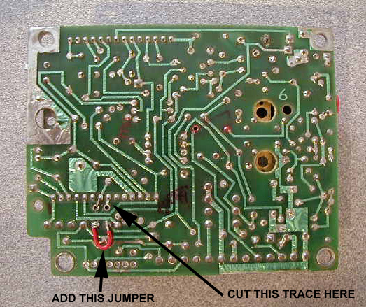

Step 4 : Hard enable the RX oscillator by placing 10V on the RX oscillator control line. This is accomplished by simply placing a jumper from J904 pin 1 to J904 Pin 2.
See red jumper in above picture.

Step 5: Defeat the RX mute circuit at U902 pin 6. Cut the trace from U902 pin 6 to J902 pin 5. It is best to cut this trace at the point that it makes an “S” pattern near pin7 of J905 and H-11. This trace runs near a square post J-11. Be certain you are severing the proper connection or CAS circuit could be disabled. See picture

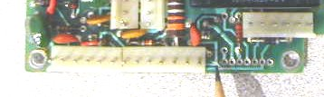
Step6: If your radio had a Channel Guard Encode/Decoder board installed, you will need to Re install R33, a 1K ohm 1/4w resistor from H-1 to H-2. H1 and H2 are holes in the PCB just behind J906. Be certain the resistor lead does not contact and short against the square post J10. See Picture below:

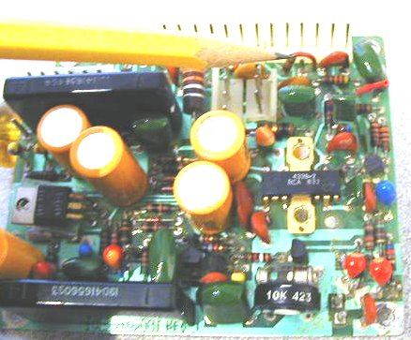

Your systems board duplexing mods are now complete. Go back and carefully check your work.

Note: A .1-inch center header fits nicely into the row of holes denoted on the PCB as H11 through H17. I install a header here so I can pickup the PTT line without soldering. Do this now before you re-install the System-Audio-Squelch PCB.

7: Re-install your System-Audio-Squelch PCB in the reverse order in which you removed it. Be careful to properly re-install the insulator over and under the TO-220 voltage regulator transistor. Install all other screws previously removed.

Re-test your MVP now. It should receive and transmit simultaneously now. If you have problem at this point do not proceed until you have the radio working correctly.

Controller installation and hookup
Install your NHRC-4/MVP controller in place of the Channel Guard Encoder/Decoder you have discarded. Use the 3 screws leftover from the removal to mount your controller. If needed obtain some 6-32 X 1/4 inch pan head screws to mount your controller to the mounting bosses on the MVP.

Care must be taken to avoid shorting the transistors which are mounted on the end of the controller next to the inside of radio. The use of electrical tape or some other insulating material between the transistors and the radio is highly recommended.

Use connectors to make your connections to the controller and systems board. This will make your installation look professional and be more reliable. Controllers received for repair with solder on the header pins will have the header pins replaced at the customer’s expense.

All connections to the controller are easily available on the System-Audio-Squelch PCB next to the controller.

1. 10VDC: Connect a wire from J906 pin 10 to J4 Pin1 of the NHRC-4/mvp

2. CAS: Connect a wire from J906 pin 5 (was rx mute) to J4 pin 2 of the NHRC-4/mvp

3. PTT: Connect a wire from H17 to J4 pin 3 of the NHRC-4/mvp

4. RX AUDIO from the Receiver: Connect a wire from J906 pin 4 ( VSQ-hi) to 5 to J4 pin 4 of the NHRC-4/MVP

5. TX AUDIO to the Transmitter: Connect this to the white or yellowish-white wire that is or was connected to J13. If this is still connected to J13 disconnect it and connect it to J4 pin 5 of the NHRC-4/mvp. Note that this wire is MIC-HI and J13 is the MIC-BIAS voltage supply. This disconnects the MIC bias and will defeat the external microphone. If a local Mic is desired, seek an alternate way to provide audio to the exciter. There may be audio loading issues with the local mic.

6. DIGITAL OUTPUT/FAN CONTROL: This connection is optional. If you desire to use this feature, the now unused hang up lead from the old channel guard board is an easy way to get this signal out of the radio. The channel hang-up lead comes out on the power/speaker jack on pin 8.

7. GROUND: Connect J906 pin 1 to J4 pin 8 of the NHRC-4/MVP.

Connections are now complete for basic repeater operation.

Before powering on your repeater go back and check your work. Apply power with the controller disconnected and check your power supply connections. With a grounded probe touch the PTT pin, your MVP should transmit.. Check to see that your CAS signal goes to aprox 7 volts when the squelch opens and goes low when it closes.

Refer to the NHRC4/MVP operating instructions for setup and operating information

